Comprehensive HealthCare Systems
Of the Palm Beaches, Inc. “From Pain to Wellness"

Fred C. Blumenfeld, D.C. 4676 Okeechobee Blvd.
Albert S. Jerome, D.C. West Palm Beach, FL 33417
Chiropractic Physicians 561-684-0710 Phone
561-689-7571 Fax
Wpbchiro.com
Email: backcare1@gmail.com
Registration and History
Date: ____________

Social Security Number |  |  |  |  |  |  |  | Date of Birth
Last Name |  |  |  |  |  |  | First Name
Address
City |  |  |  |  |  | State |  |  |  |  | Zip Code
Home Phone |  |  |  |  |  | Cell Phone

Sex Male Female Age ____

Are you pregnant? ____Yes ____ No if yes, Due Date ________

___ Married ___ Widowed ___ Single ___ Minor ___ Separated ___ Divorced

Patient Employer
Occupation

In Case of Emergency, Contact

Name: ______________________________________ Relationship _________________
Home Phone: ________________________________ Cell Phone: __________________
Accident Information
Is this condition do to an injury? Yes No Date of injury ________________
Type of injury ____Auto _____Work _____Slip and fall _____Other, explain____________
To who have you made a report of your injury?
Auto insurance Employer Worker Comp. Other_________________________
Name of your insurance company_____________________________________________

Patient Condition
Reason for visit ___________________________________________________________
When did your symptoms appear? ____________________________________________
Is this condition getting progressively worse? Yes No Unknown

Mark an X on the picture where you continue to have pain, numbness, or tingling.
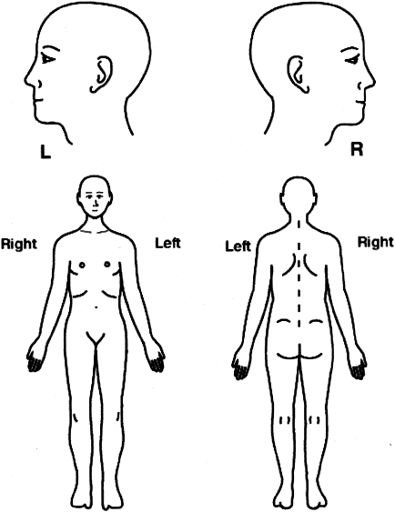
Type of pain circle all that apply: Sharp - Dull – Throbbing – Numbness – Aching – Shooting – Burning – Tingling – Cramps – Stiffness – Swelling – Other
How often do you have this pain? _____________________________________________
Is it constant or does it comes and goes? _______________________________________
Does it interfere with your Work Sleep Daily Routine Recreation
Activities or movements that are painful to perform Sitting Standing Walking Bending Lying Down
Patient Social History:
Use of Alcohol | Never | Rarely | Moderate | Daily
Use of Tobacco | Never | Rarely | Moderate | Daily
Use of Drugs | Never | Type/Frequency

Do you have any known allergies to either medications, environmental, or food related?
О NO О Yes if yes what type: ______________________________________________

Past Medical History

Illness__________________________________________________________________________________________________________________________________________________________________________________________________________________________________________________________________________________________

Injuries_________________________________________________________________________________________________________________________________________________________________________________________________________________________________________________________________________________________

Past Injuries/Surgeries
- Falls ______________________________________________________________
- Head Injuries _______________________________________________________
- Broken Bones ______________________________________________________
- Dislocations _______________________________________________________
- Surgeries __________________________________________________________
- Other _____________________________________________________________
- Prior Automobile Collisions __________________________________________

Previous Hospitalizations/Surgeries/Serious/Illnesses When? Hospital, City, State
_______________________________________________ _____________ ________________________
_______________________________________________ _____________ ________________________
_______________________________________________ _____________ ________________________
Medication: (include nonprescription)
________________________________________________________________________________________________________________________________________________
________________________________________________________________________

